

DEPARTMENT OF COMPUTER SCIENCE – UBIT

“Assembly language”

CSSE – 403

Chaudhary Usama Ishtiaq

Section ‘A’ (EVENING)

EB23210106023

Submitted to: SIR FAROOQ

ASSIGNMENT-05

**LAB: 05**

**Objective 01**: Write a program to print ‘*’ 100 times using linefeed and carriage return.

**Input:**

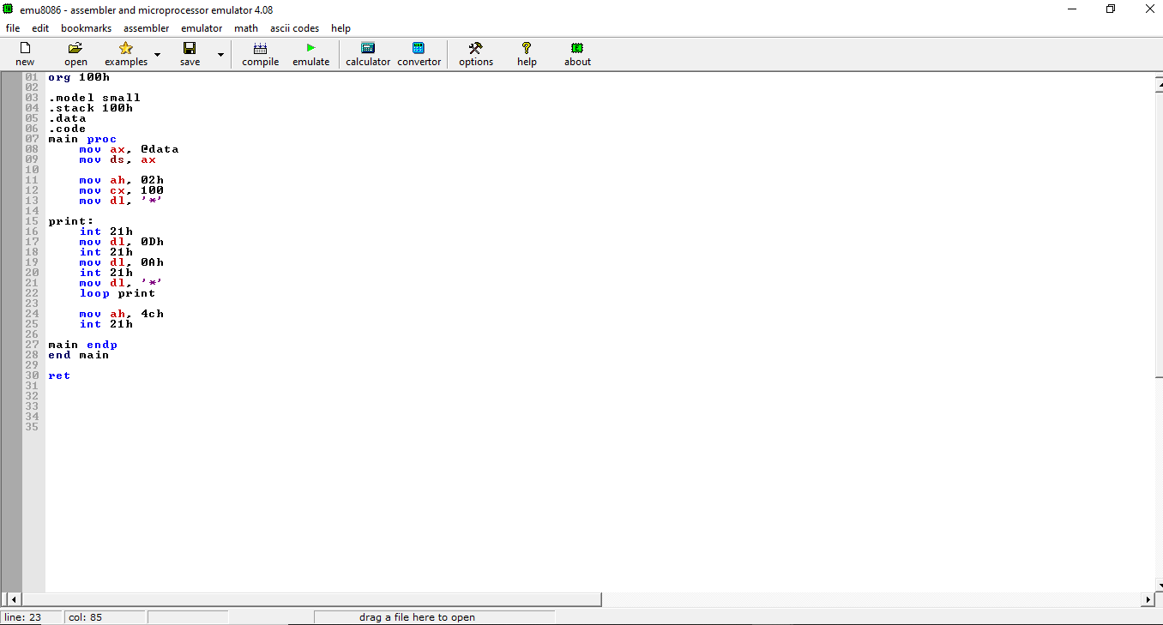

**Output:**

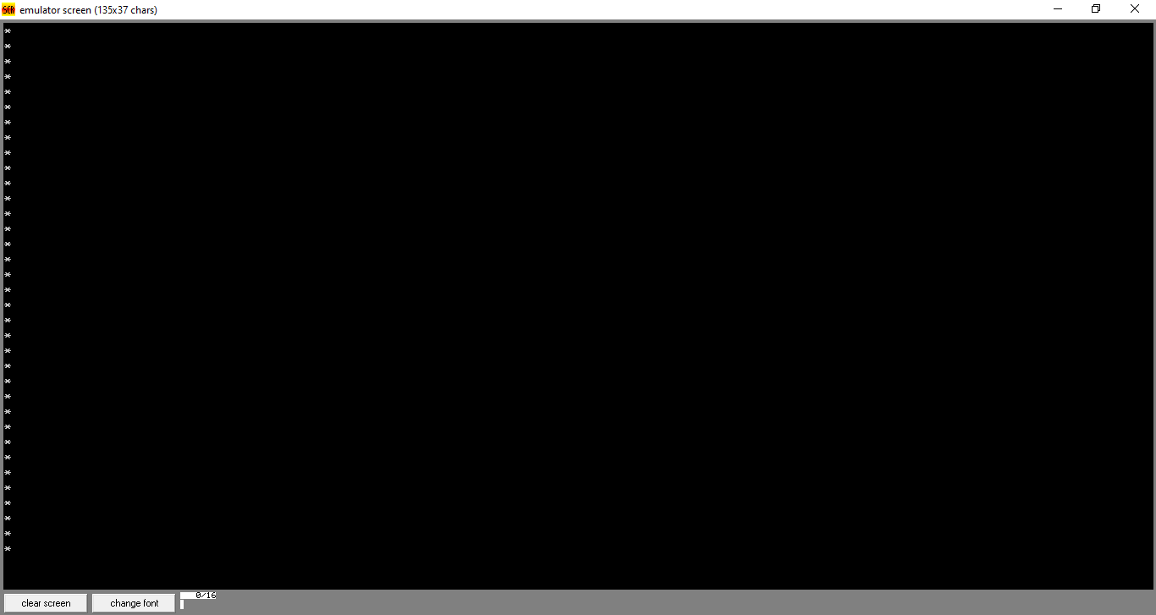

**Objective 02**: Write a program to print ASCII characters from A-Z and Z-A

**Input:**

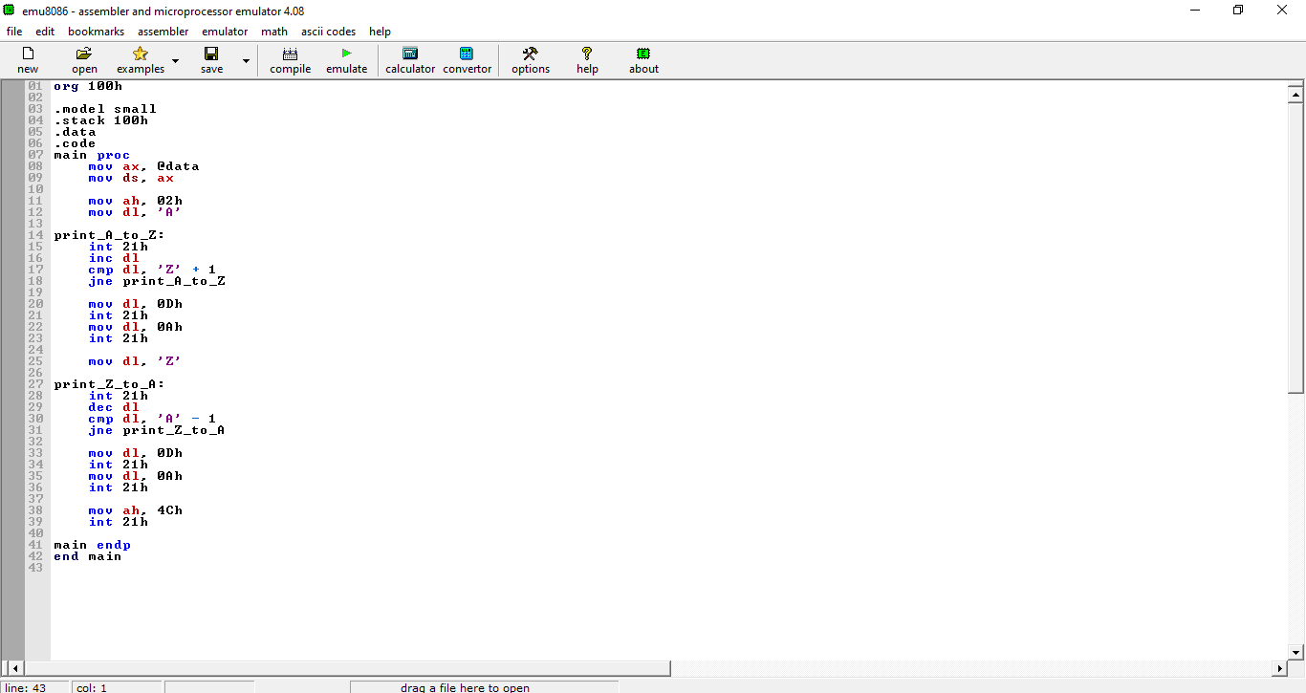

**Output:**

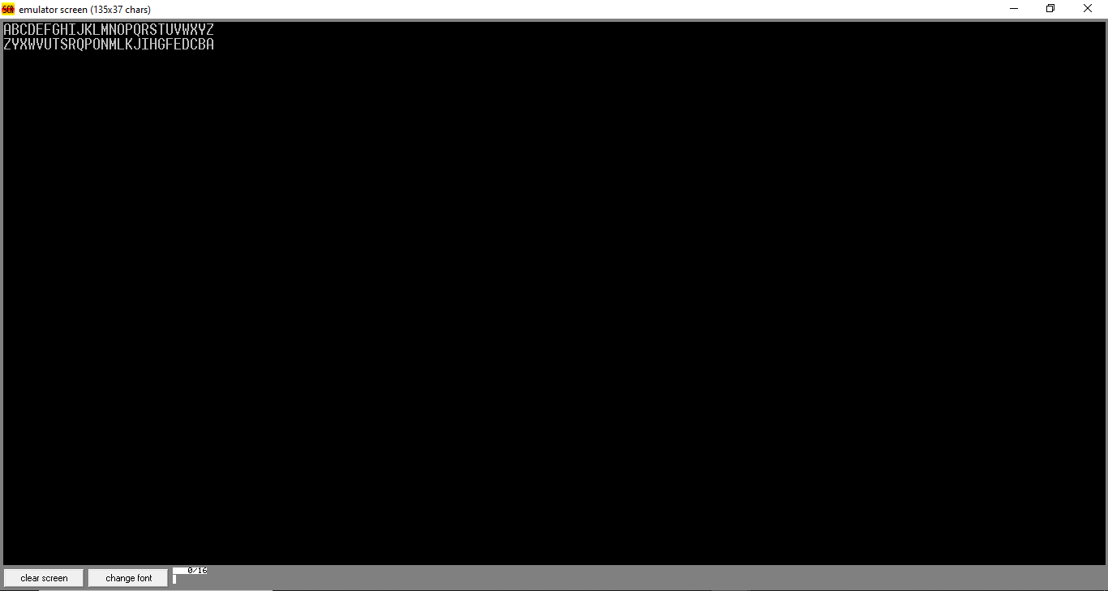

**Objective 03**: Write a program to print ASCII characters from a-z and z-a

**INPUT:**

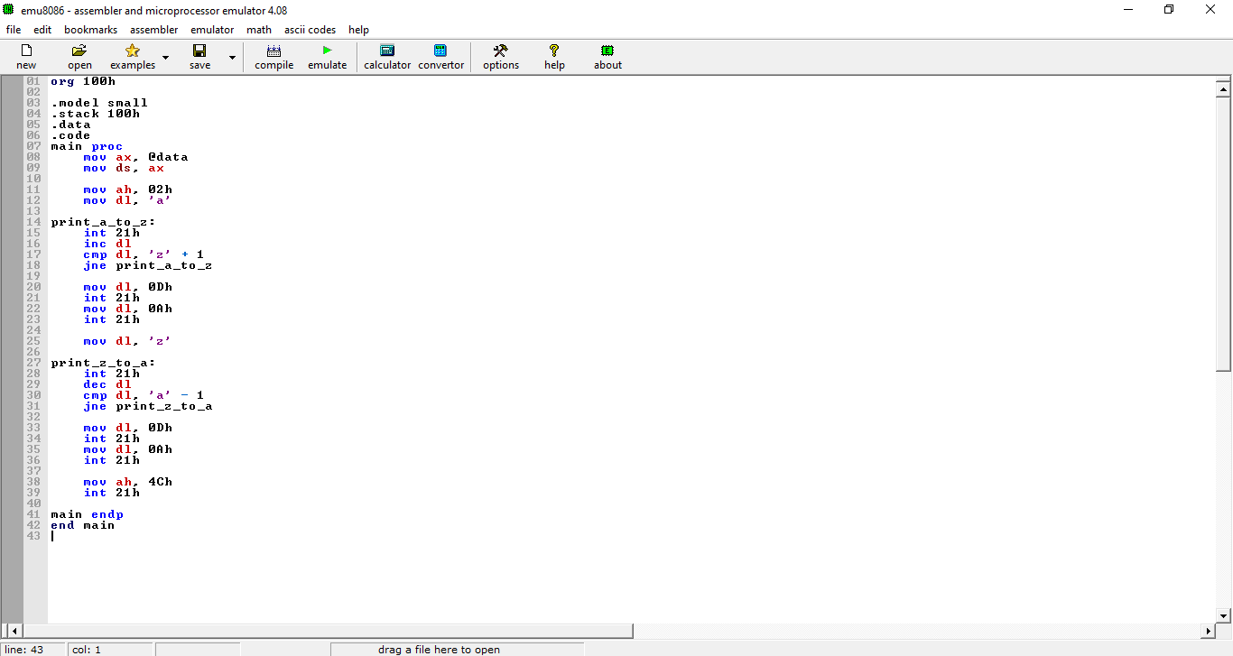

**OUTPUT:**

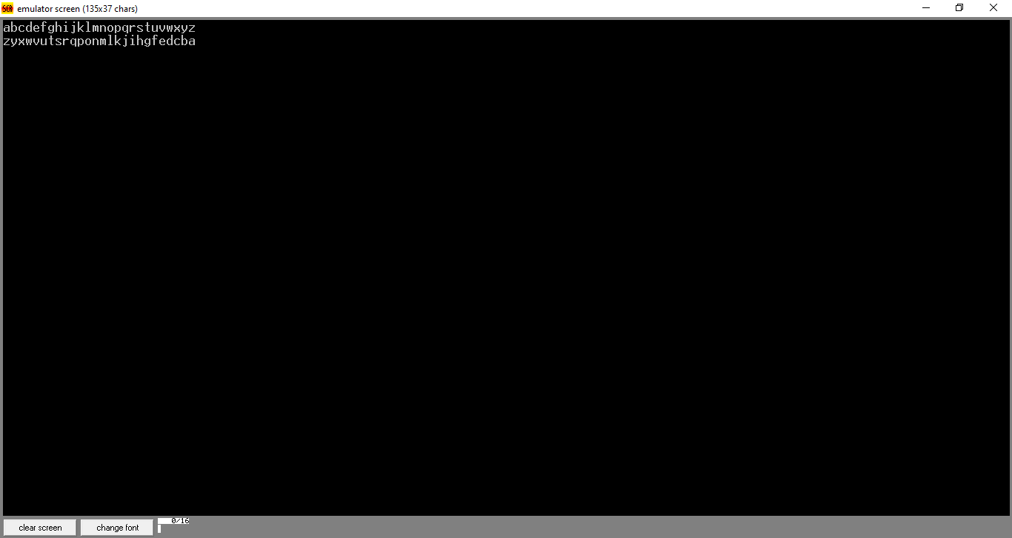

**Objective 04**: Write a program to print ASCII characters.

**Input:**

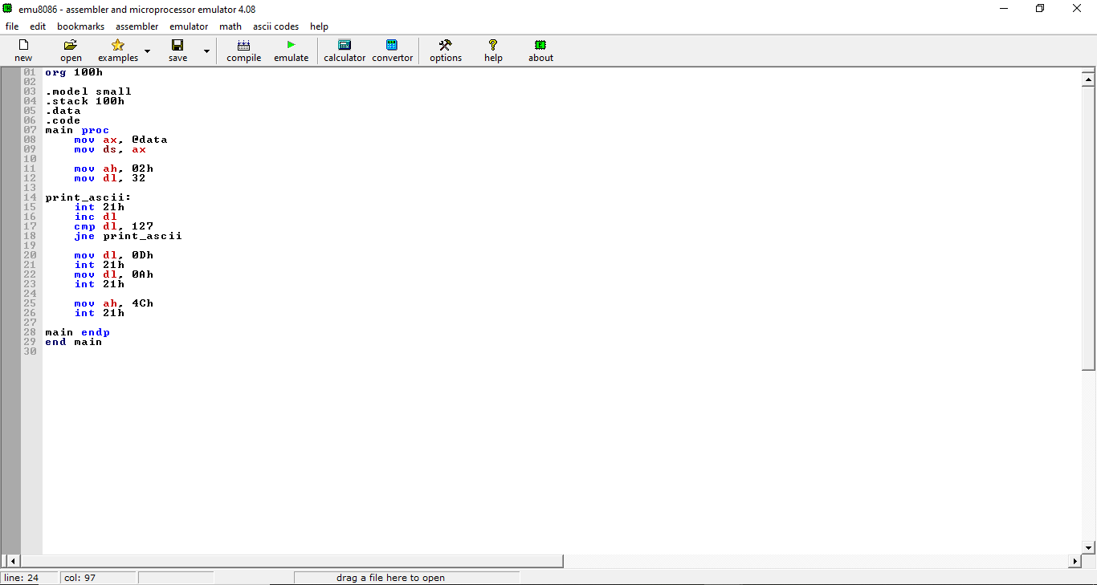

**Output**:

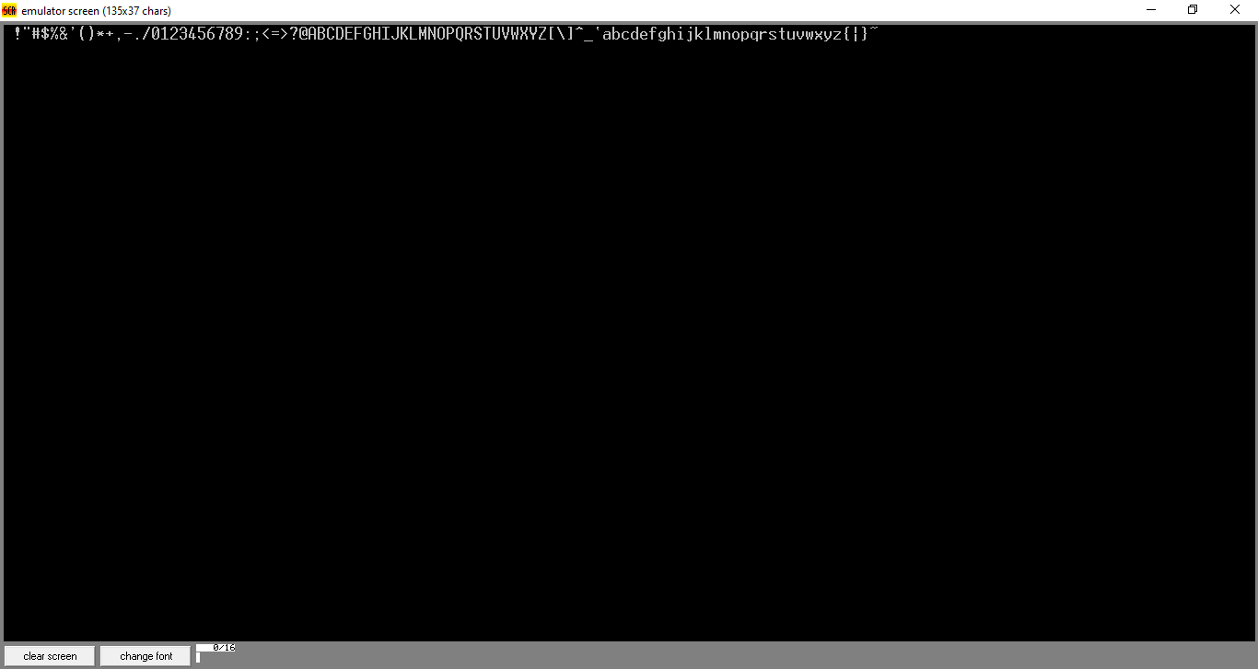

**Objective 05**: Write a program to print your name 10 times using linefeed and carriage return.

**Input:**

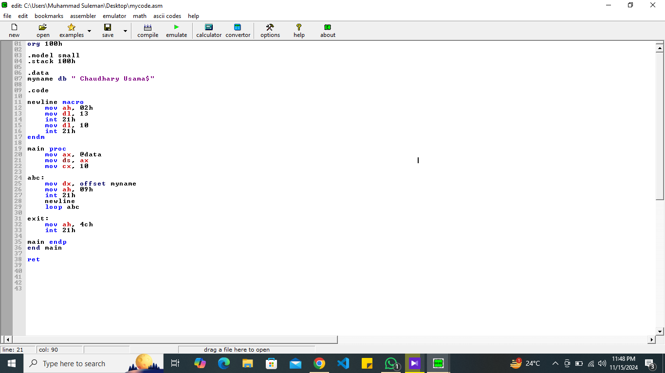

**Output:**

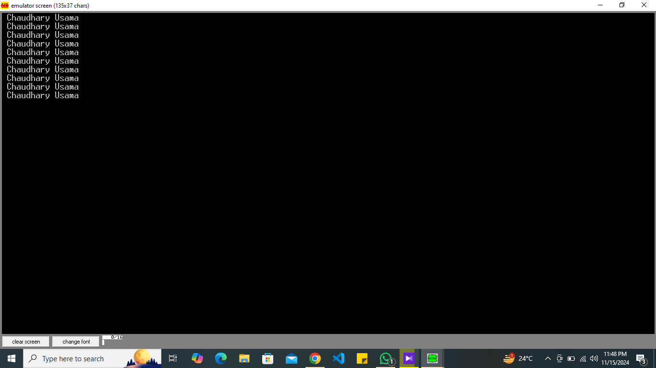

**Objective 06:** Display printable key strokes of a keyboard until user prints Escape “Esc” key (Hint: ASCII code of Esc is 27).

**Input**:

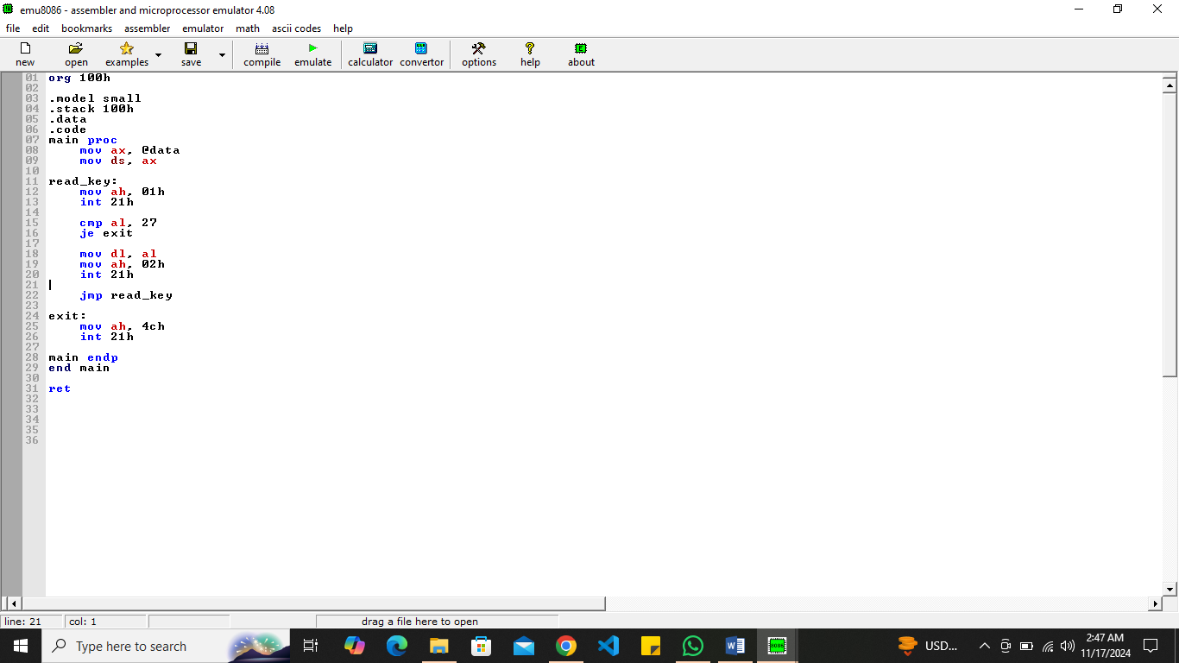

**Output:**

